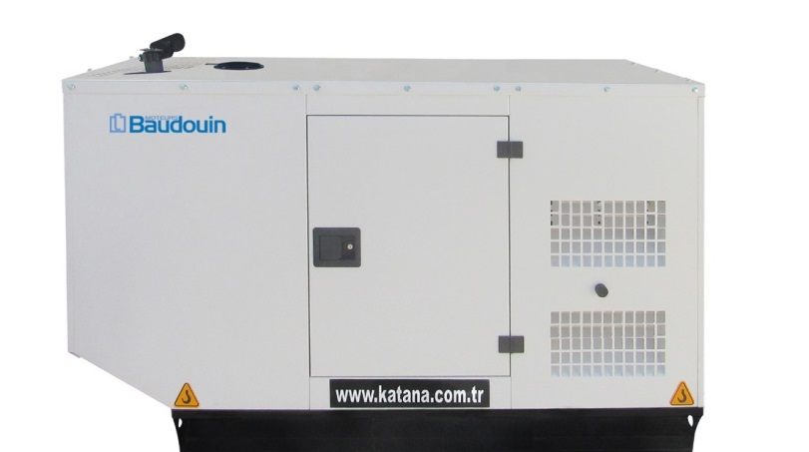
Technicial Specification

Diesel Generator Set KD 25 B&M

Description

This Katana® Power Generation commercial generator set is a fully integrated power generation system, providing optimum performance, reliability, and versatility for stationary standby, prime power and continuous duty applications.

Features

Katana® heavy-duty engine - Rugged 4-cycle industrial diesel delivers reliable

power, low emissions and fast response to load changes.

Alternator - Low reactance 2/3 pitch windings; low waveform distortion with non- linear loads, fault clearing short- circuits capability, and class H insulation.

Cooling system - The standart integrated kit model radiator system designed and tested for nominal ambient temparatures, simplifres facility design requirements for heat rejected.

Control system – Datakom electronic control is standard equipment and provides total genset system integration, including auto remote start/stop, alarm and status message display.

Canopy Types - Optionally it is possible to make it protective and soundproof against adverse climatic conditions

Warranty and service - Backed by a comprehensive warranty and worldwide aftersales support, 10 years of spare parts supplying.

Stand by Rating (ESP): It is the way that generators operate under variable load at certaintime ıntervals. It can work as a backup power.It is not suitable to work under extreme load.

Prime Rating (PRP): Applicable for supplying power to varying electrical load for unlimited hours. PRP is in accordance with ISO 8528. 10 % overload capability is available for a period of 1 hour within
12-hour perod of operation,in accordance with ISO 3046.

Genset Model | Engine Model | Prime rating | Stand by rating
KD 25 B&M | 4M06G25/5 | 21 kVA | 23 kVA

www.katana.com.tr
Manufacturer reserves the right to make changes in model, technical specifications, color, equipment and accessories without prior notice.

Generator Set Specifications

Governor regulation class | ISO 8528 G3
Voltage regulation, no load to full load | ± 1%
Random voltage variation | ± 1%
Frequency regulation | Isochronous
Random frequency variation | ± 0.25%
EMS compatibility | In compliance with BS 800 and VDE levels G and N
Engine Specifications

Engine brand | Baudouin Engine
Aspiration Type | Natural
Engine Rated Speed | 1500 RPM
Bore | 89 Mm
Stroke | 92 Mm
Displacement | 2,3 L
Cylinder block | 4 cylinder,vertical
Oil Capacity | 7.1 L
Coolant Capacity for Engine | 5 L
Starting voltage | 12 V
Fuel system | Direct injection
Fuel filter | Strata pore fuel filter
Air cleaner type | Heavy duty air cleaner
Compression ratio | 17.5 : 1
Cycle | 4 stroke
Cooling system | Liquid (water + 50% antifreeze)
Governor Type | Electronic
Fuel Consumption at 25% of generator set prime output Fuel Consumption at 50% of generator set prime output Fuel Consumption at 75% of generator set prime output Fuel Consumption at 100% of generator set prime output | 2 L/H  3.2 L/H  4.5 L/H  6.1 L/H
Alternator Specifications

Alternator brand | Megatron
Type | Brushless, revolving field
Frequency | 50 Hz
Winding pitch | 2/3 pitch
Number of bearing | Single bearing
Protection | IP23
Insulation system | Class H
Standard temperature rise | Standart 125ºC ,Stand by 163ºC
Exciter type | Self - excitation or other excitation by PMG
Phase rotation | A (U), B (V), C (W)
Alternator cooling | Direct drive centrifugal blower fan
AC waveform total harmonic distortion (THDV) | No load <1.5%. Non distorting balanced linear load <5%
Telephone influence factor (TIF) | <50% per NEMA MG1-22.43
Telephone harmonic factor (THF) | <2%
Generator Set Options

Engine
Alternator Base frame
Canopy Types

Water jacket heater
H class insulation Exciter voltage regulator
Double wall fuel tank
Optional super silent

Cooling Control panel
Antifreeze -25° Datakom
3 pole main circuit breaker
Motorised 4 pole circuit breaker
Warranty
Global warranty

Control system
The new D300 MK2 genset controller is a cost effective modular genset controller ready for internet monitoring through plug-in modules.
Its main advantages are multifunctionality, support for multiple topologies, harmonic analysis and detailed power measurements.

Description

Software features are complete with easy firmware upgra- de through USB port.

The Windows based PC software allows monitoring and programming through USB, RS-485, RS-232, Ethernet and GPRS.

The Rainbow Scada web service allows monitoring and control of an unlimited number of gensets from a single central location

Major features
- Diesel and gas genset support
- 400Hz operation support
- 400 event logs, full snapshot
- All parameters front panel editable
- 3 level configuration password
- 128x64 graphical LCD display
- Downloadable languages
- Waveform display of V & I
- Harmonic analysis of V & I
- 16Amp MCB & GCB outputs
- 8 configurable digital inputs
- 6 configurable digital outputs
- 3 configurable analog inputs
- Both CANBUS-J1939 & MPU
- 3 configurable service alarms
- Multiple automatic exerciser
- Weekly operation schedule
- Dual mutual standby with equal aging of gensets
- Manual “speed fine adjust” on selected ECUs
- Automatic fuel pump control
- Disable protections feature
- Excess power protection
- Reverse power protection
- Overload IDMT protection
- Load shedding, dummy load
- Multiple load management
- Current unbalance protection
- Voltage unbalance protection
- Fuel filling & fuel theft alarms
- Battery back-up real time clock
- Idle speed control
- Battery charge run enabled
- Combat mode support
- Multiple nominal conditions
- Contactor & MCB drive
- 4 quadrant genset power counters
- Mains power counters
- Fuel filling counter
- Fuel consumption counter
- Modem diagnostics display
- Configurable through USB, RS-232 and GPRS
- Free configuration program
- Allows SMS controls
  - Ready for central monitoring
  - Mobile genset support• Automatic GSM geo-location
  - GPS connectivity (RS232)
  - Easy USB firmware upgrade
  - IP65 rating with optional gasket

Functions
  - AMF unit
  - ATS unit
  - Remote Start Controller
  - Manual Start Controller
  - Engine Controller
  - Remote Display Panel

Communications
  - USB Device
  - J1939-CANBUS
  - Geo-locating through GSM
  - Internet Central Monitoring
  - SMS Message Sending
  - E-mail Sending
  - Free Pc Software: RainbowPlus
  - Modbus RTU (2400-57600baud)
  - Modbus TCP/IP
  - HTML
  - UDP

Remote monitoring
  - Single server supports up to 60’000 devices
  - Provides data security, data is sent to only server
  - Uses internet-based interactive World map
  - Real time display of status of devices are shown on the map, and on side panel
  - Hierarchical configuration and clustering
  - Remote control of devices
  - Supports all Datakom products, which are integrated with DKG 210 gateway
  - Supports all devices, which supports Modbus protocol, by integrating DKG 210 gateway
  - Data recording, analysis and reporting
  - Tablet and smartphone interfaces

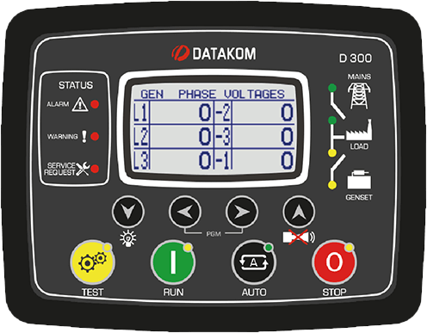
D-300 MK2 control operator / display panel

www.katana.com.tr

Canopy Standart Specifications

- Compact design connection with non-welded nuts and bolts.
- Integrated canopy,generator set,exhaust system fuel
tank.
- Body made from steel components treated with polyester powder coating
- Easy access to all service points
- Exhaust system inside canopy
- Large doors on each side
- Control panel viewing window in a lockable access door
- Emergency stop push button mounted on cabin exterior
- Fuel fill and battery can only be reached via lockable access doors.
- Customer options available to meet your applications
needs.
- Katana makes its generating sets noise level tests in accordance with directive 2000/14/EC validation of the noise level test has been aproved by the notified body Szutest (CE conformıty assessment body).

Open

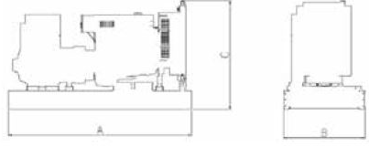

Enclosed

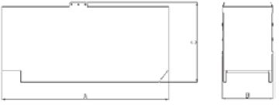

 | Dry Weight (Kg) | Lenght (Mm) | Width (Mm) | Height (Mm) | Tank Capacity (L)
Open type | 550 | 1600 | 850 | 1250 | 73,6
Canopy | 650 | 1800 | 850 | 1450 | 73,6

Certificates

Katana Generator has Quality Management Systems certificate. ISO 9001:2015

Katana Generator has Environmental Management System certification.
ISO 14001:2015

Katana Power Products
Katana Güç Ürünleri San. Tic. Ltd. Şti.

Katana Generator has Occupational Health and Safety Management Systems certificate.
ISO 18001: 2007

This generator set is available with CE certification.

Adress : Gebze Güzeller Organize Sanayi Bölgesi Yunus Emre Sok. No :3
Gebze / KOCAELI / TURKEY

Mazoji Bendrija „Techto”
+37060089799
+37060263730
Adresas Vilniaus m. Laisvės pr. 60, 6 aukštas { Vilniaus spaudos rūmai
EMAIL: nfo@trafotech.lt
www.trafotech.lt

